Assignment 6 User Interface

Luka Necajev

Daniel Morrison

Mia x

Brent Sterling

**Page Hierarchy**

Everything is connected to either the home page, or the navigation bar that follows the design of the website

Left to Right >

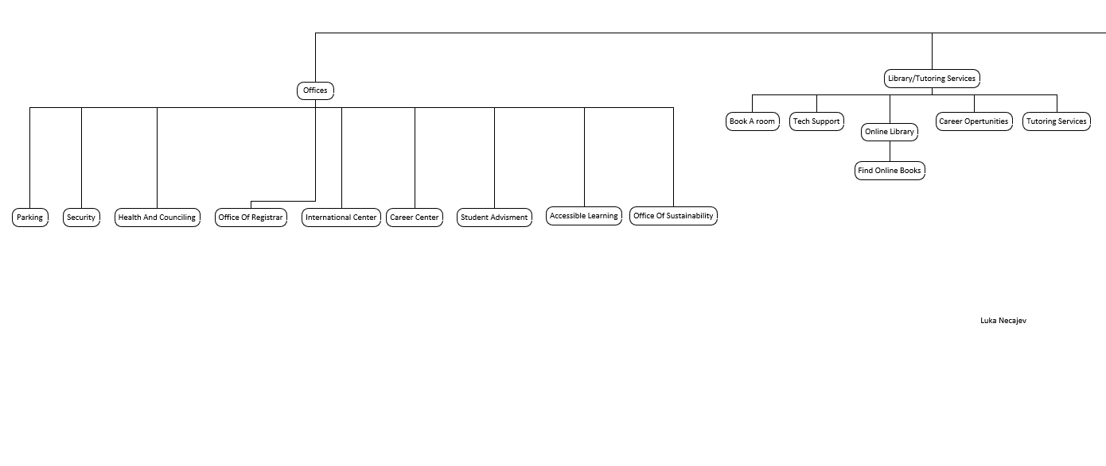

Part 2 Left to Right flow of my website design

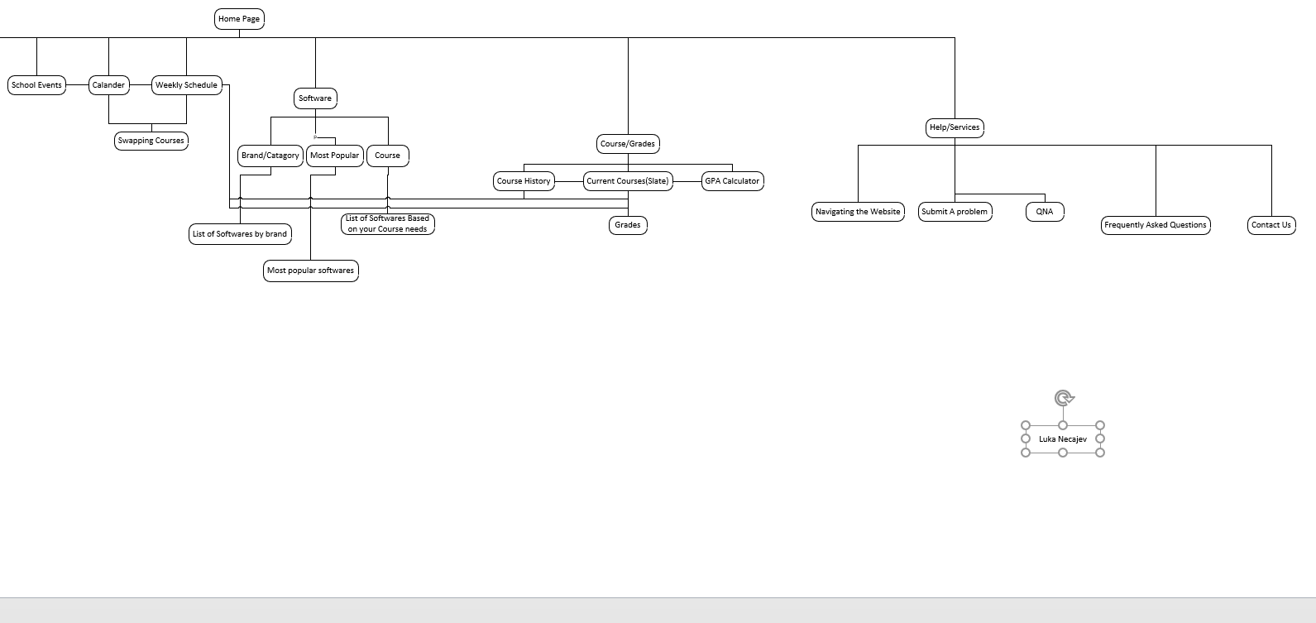

**Home Page**

Fixed up this page to make it more organized and make it much easier to navigate and move promote the right features

Top Part of the Home Page

The top part includes what used to be the student Center, but I also added a working calendar on the homepage, as well as a visual link to your weekly schedule, so you are not struggling to find it when you forget where your class is.

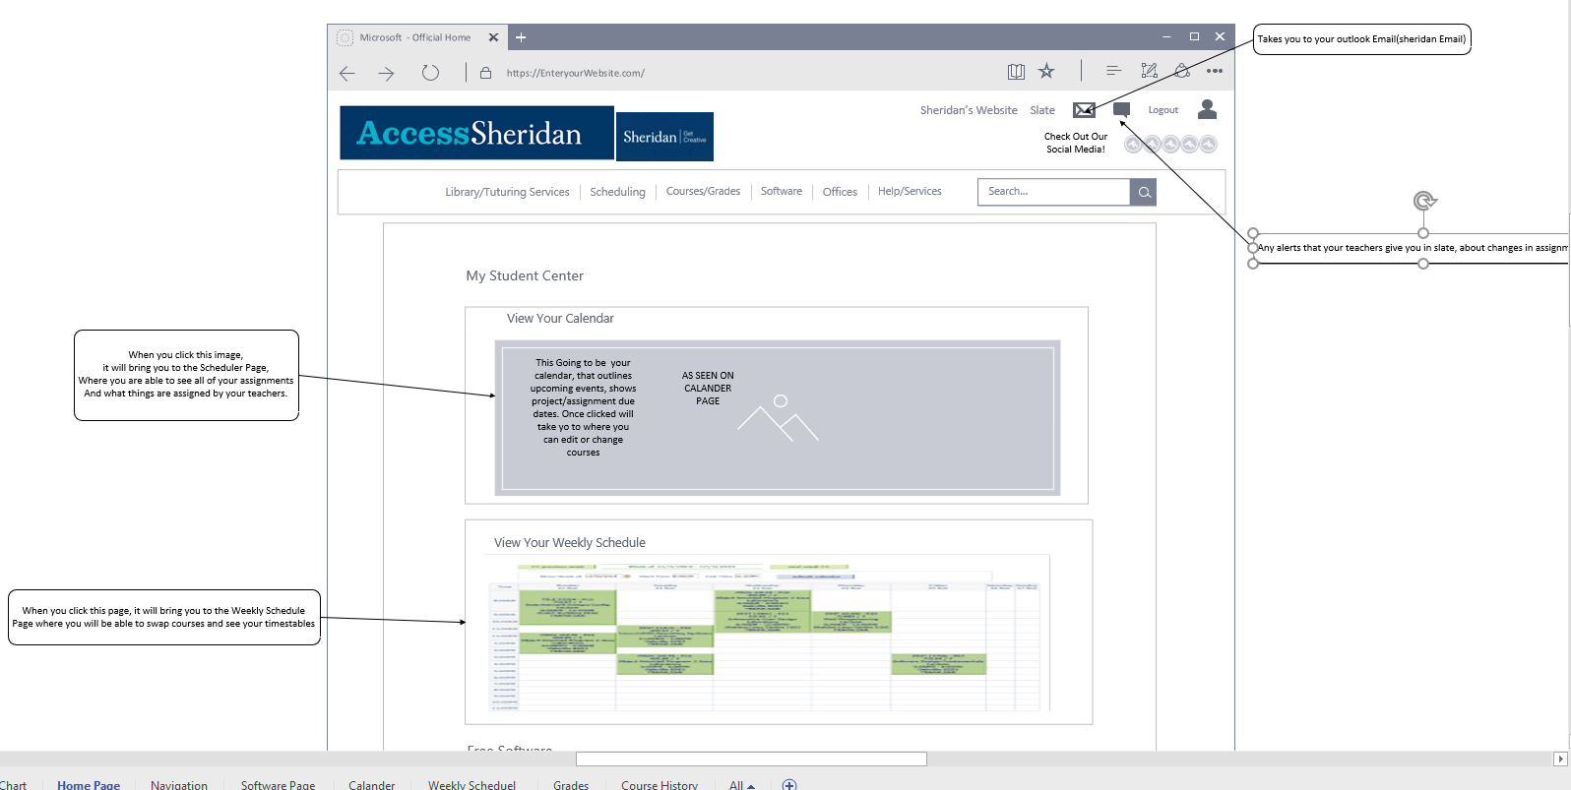

Bottom Half of the Home Page

For the bottom half of the page I added the Free software section, that was requested in the survey responses, I also added the Library and turtoring services, as I decided to merged the two to conserve space, and keep organization of the important things, while I delete the worthless links from the homepage and moved them to the QNA. I also added the Campus Services because I think that this would be a benefit to be seen visually and have a small explanation because that would save a lot of time navigating through all of the centers and services that the college offers.

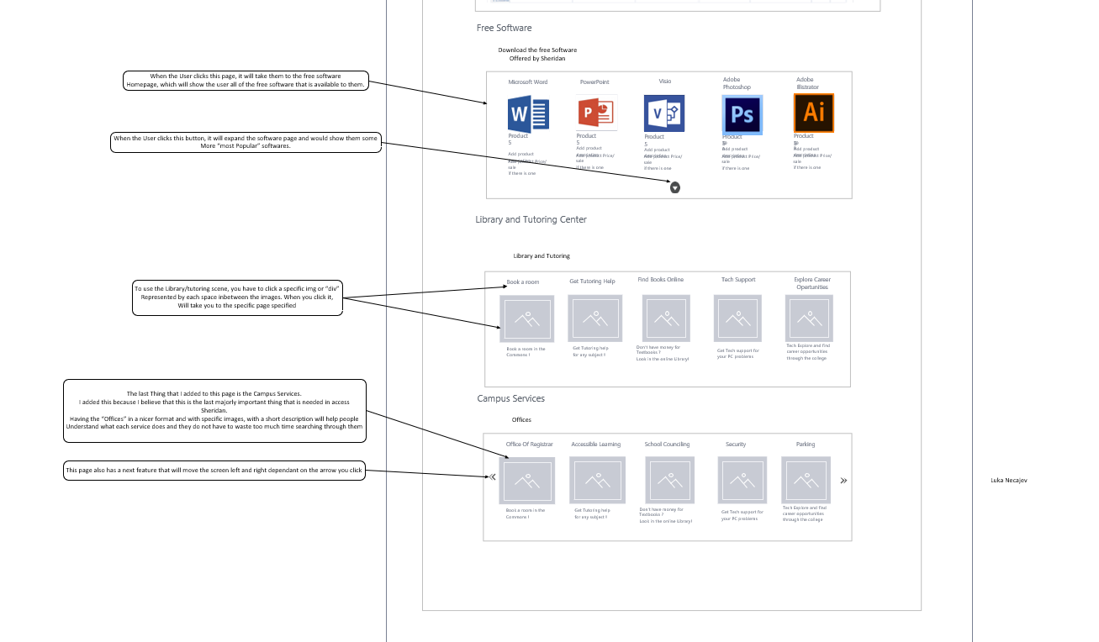

Added a navigation bar because our surveys said that the website needed to be organized better

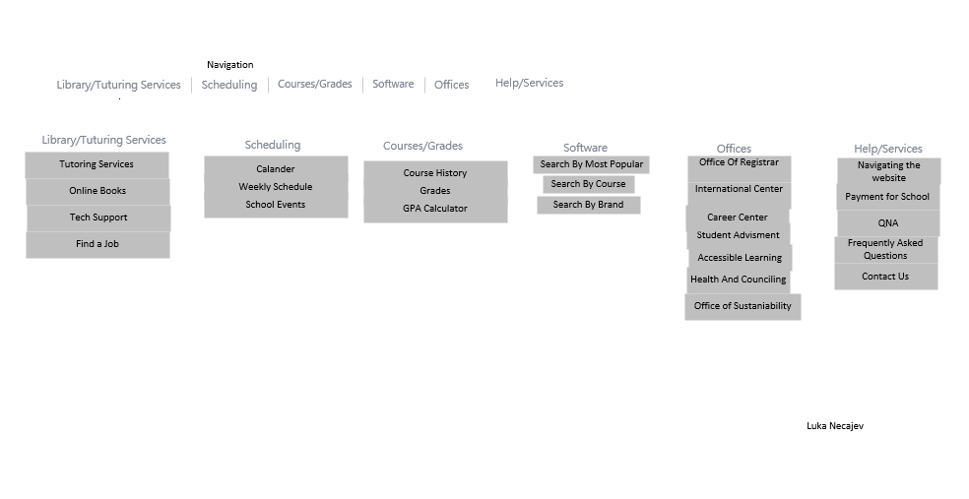

The page where users can see the Free Software’s , I added this page because almost all of the surveyers said that they did not know where to get the free softwares, so I provided them with a simple way to find it, either by popularity, brand, or course

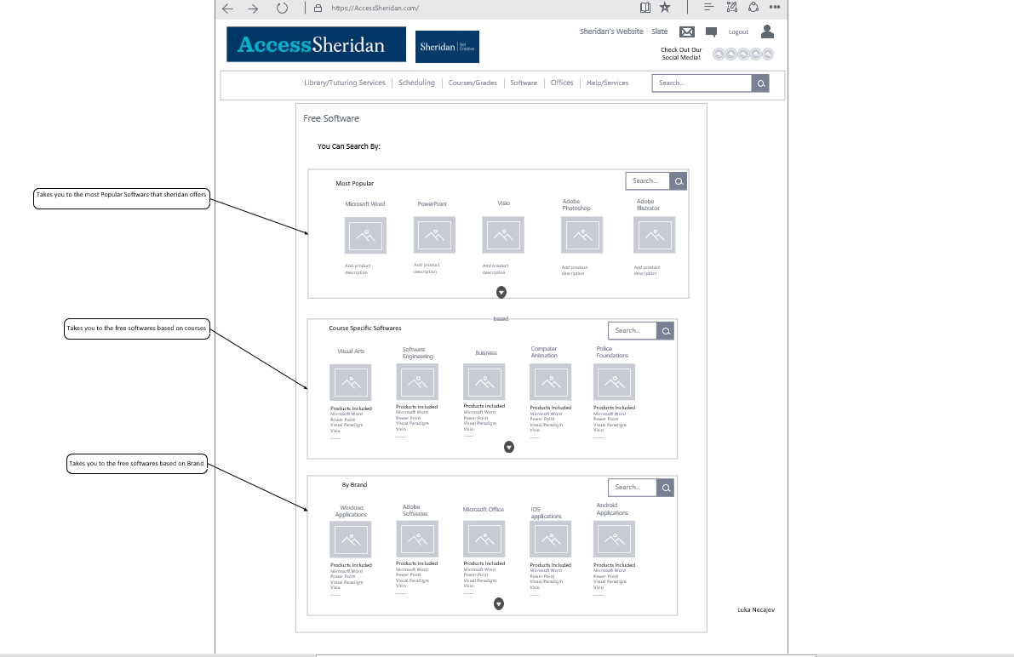

The Next thing I did was Make the Calendar feature that I enjoy a lot

Top half of the website

I made a calendar that would record your assignment dates and class dates and use them to help organize you so that you don’t miss a deadline and are prepared for your tests and quizzes, this was agreed upon the surveyor’s in our surveys as well

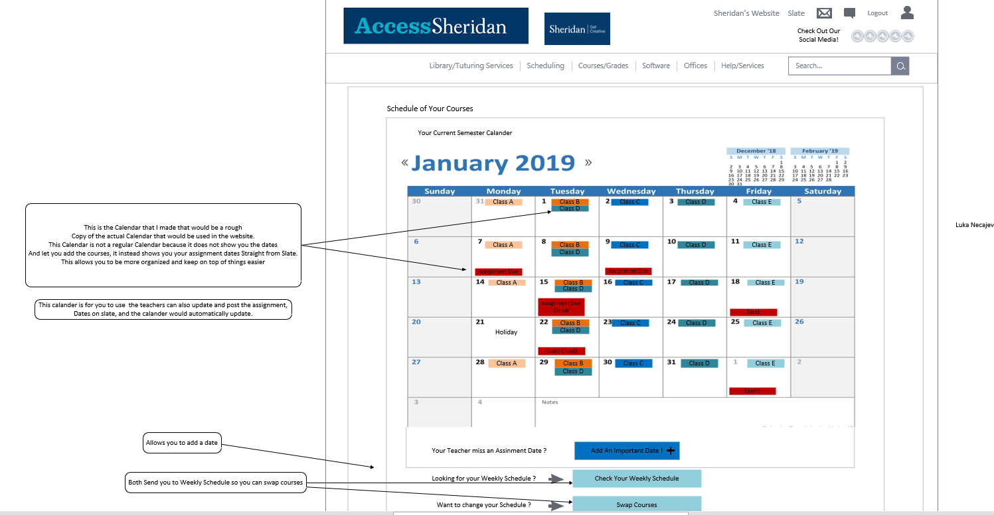

Bottom half of the website

This part of the website contains a upcoming projects and a weekly planner instead of the calendar

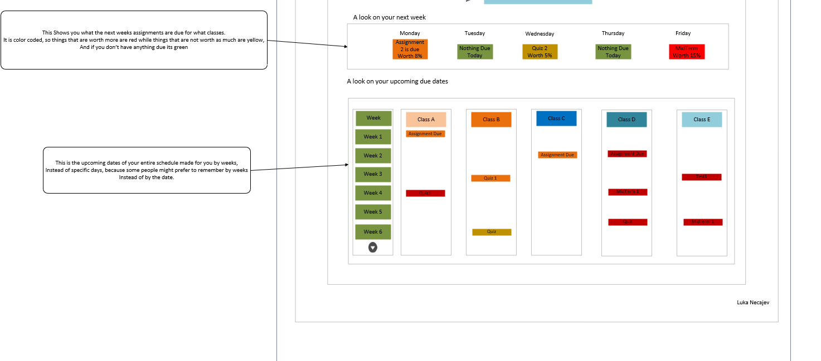

The Weekly Schedule page, I did not really change the design of the calander because the design works.

The first page I made for the weekly schedule

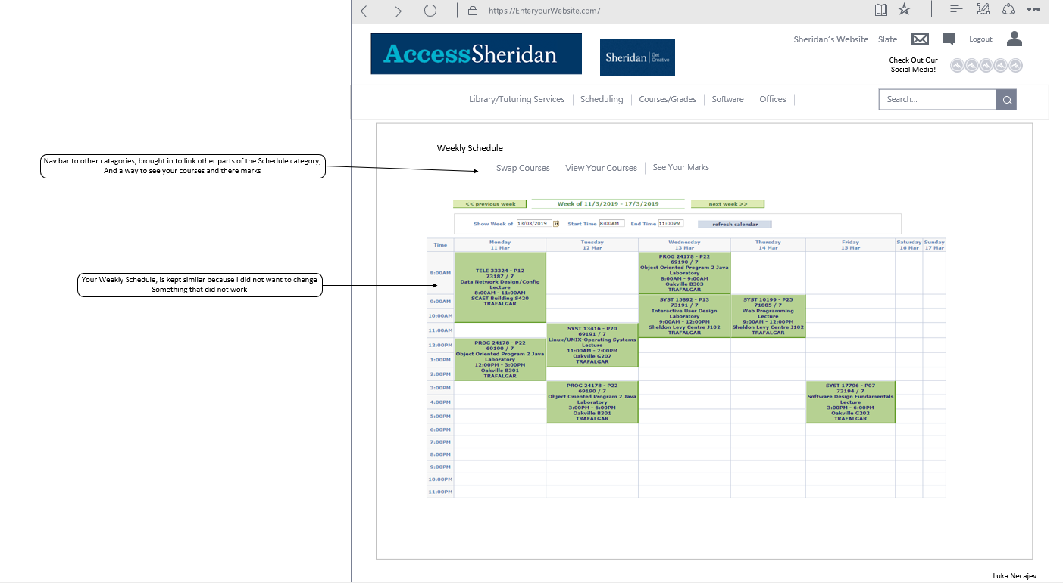

But underneath it, I have one of the two ways to swap courses

You would click swap courses then pre determined schedules, then click the schedule that suits you most, then pop up would come and you would hit okay, and bang your done, no struggles to drop courses and re apply them to another course, by going through multiple pages for each course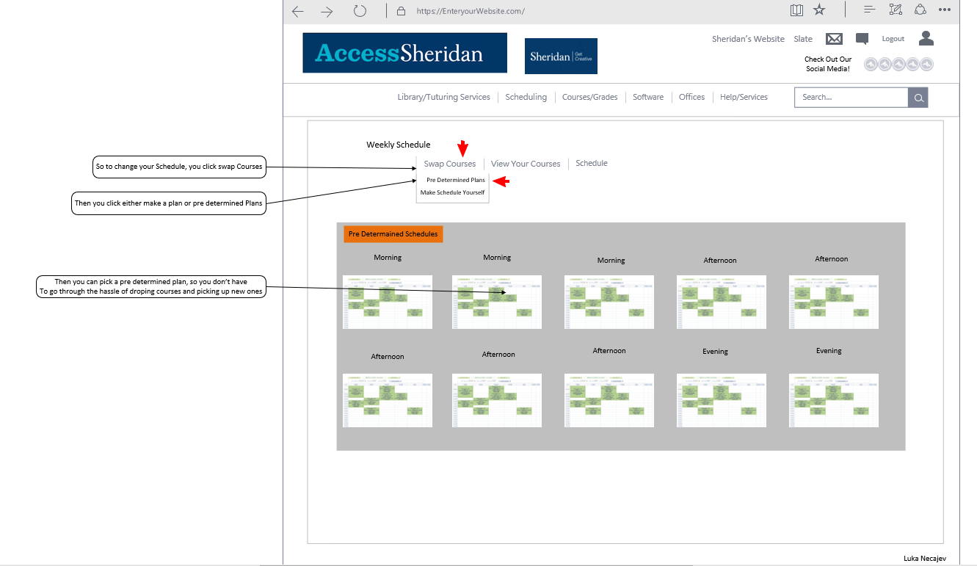

The next thing I did was create the grades section.

The top half

The top half includes the course history, and your current grades this semester

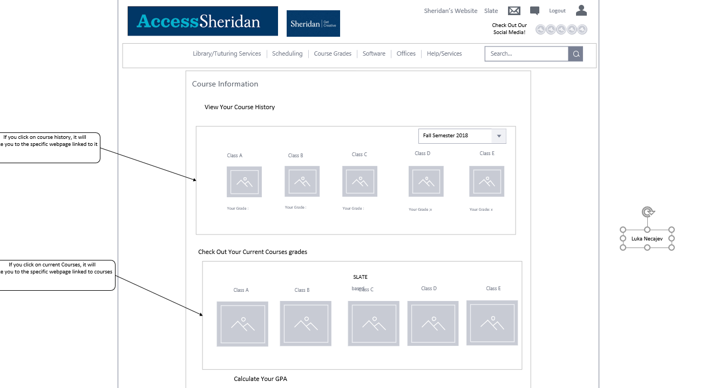

And the bottom half

Contains the GPA calculator would calculate your gpu and give you options to alert you when your grades are lower then the 70 or lower then a value you type in

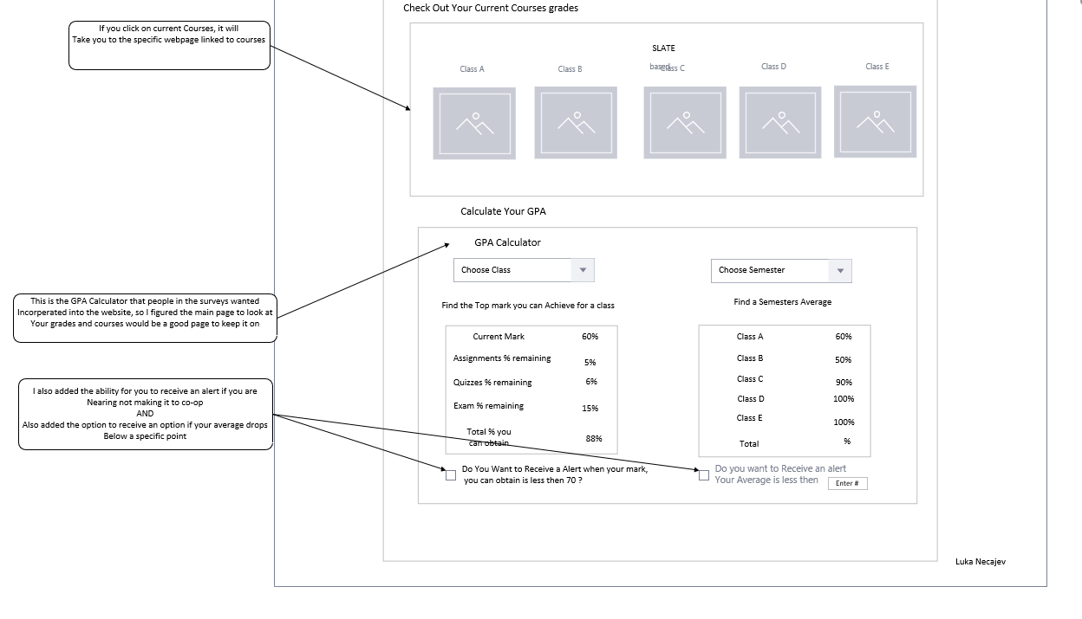

The last Page I made was the Course History tab, this would be accessed when you click the Course Grades, and then course history

